**Accounting voucher**

n Tally, a voucher is a document containing all of the details of a financial transaction and is required to record in the books of accounts. They are simple to create and modify. A voucher is a document containing details of a financial transaction and is required to record the same in the books of accounts. For every transaction, you can use the appropriate Tally voucher to enter the details into the ledgers and update the company’s financial position.

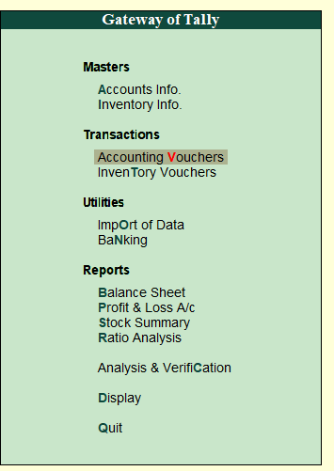

**Predefine** **voucher**

Tally comprises the following predefined Vouchers, to suit different business requirements for recording various transactions. Tally also allows you to create user-defined Vouchers (Voucher Types) as per your requirements.

● Contra Voucher

● Payment Voucher

● Receipt Voucher

● Journal voucher

● Sales Voucher / Invoice

● Debit Note Voucher

● Credit Note Voucher

● Purchase Voucher / Invoice

The voucher entry menu options are available under Transactions in the Gateway of Tally.

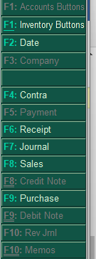

**To create an entry in the accounting voucher**

Go to the gateway of tally and click on accounting voucher or press v from a keyboard. Here you can create various types of vouchers as per your requirement.



**Payment voucher(F5)**

A payment voucher is used to account for all the payments made by the company by way of Cash/Bank. Payment vouchers can be passed using Single Entry or Double Entry mode by configuring the setting Use Single Entry mode for Pymt/Rcpt/Contra in F12 configuration.

Examples:-

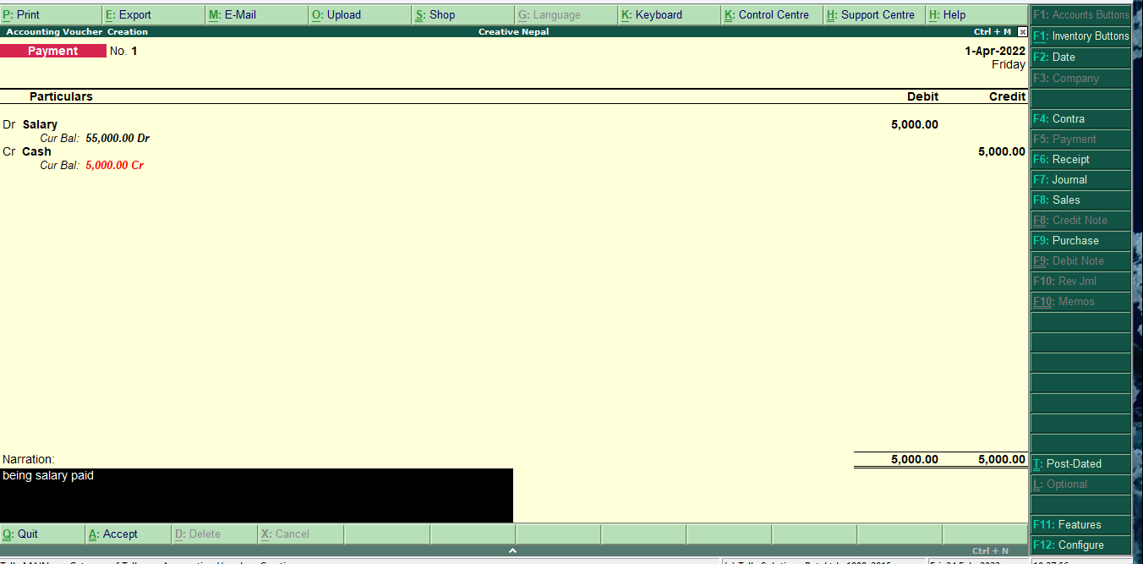

**Salary paid of Rs. 6000**

Salary a/c ………Dr. 6000

To cash a/c………6000

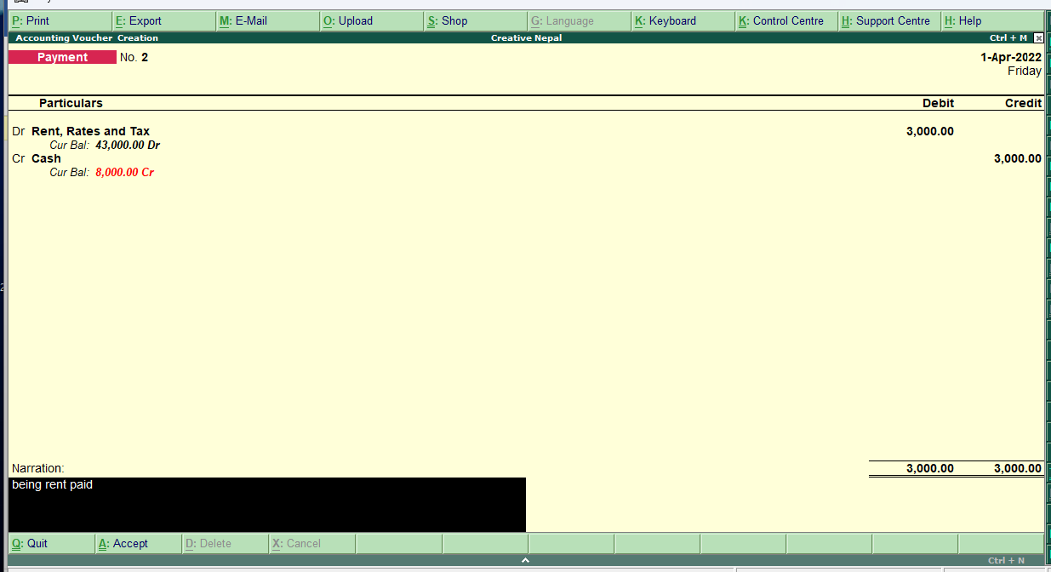

**Rent, rate, and tax**  **paid of Rs. 3000**

Rent rate and tax a/c ………Dr 3000

To cash a/c……….3000

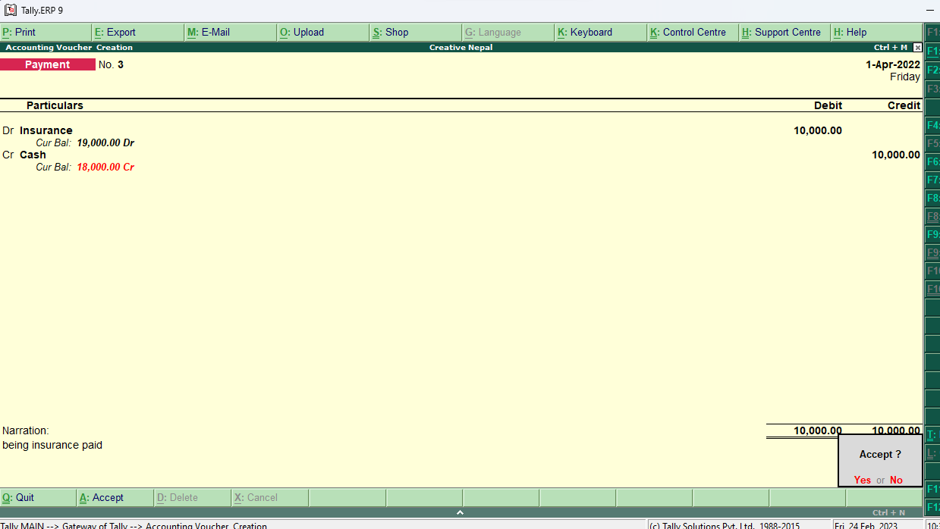

**Insurance paid of Rs 10000**

Insurance a/c ………Dr.10000

To cash a/c………..10000

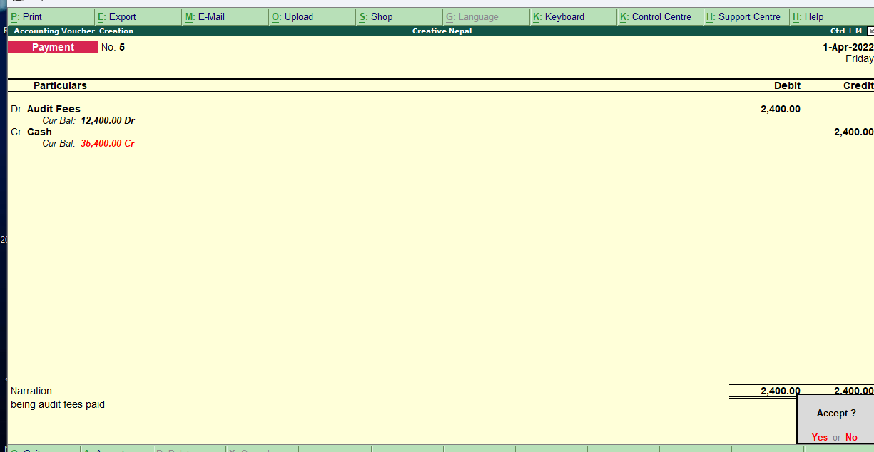

**Audit fee paid Rs 12,400**

Audit fee a/c ………Dr.12,400

To cash a/c………..12,400

**wages paid Rs 45,000**

wages a/c ………Dr.45,000

To cash a/c………..45,000

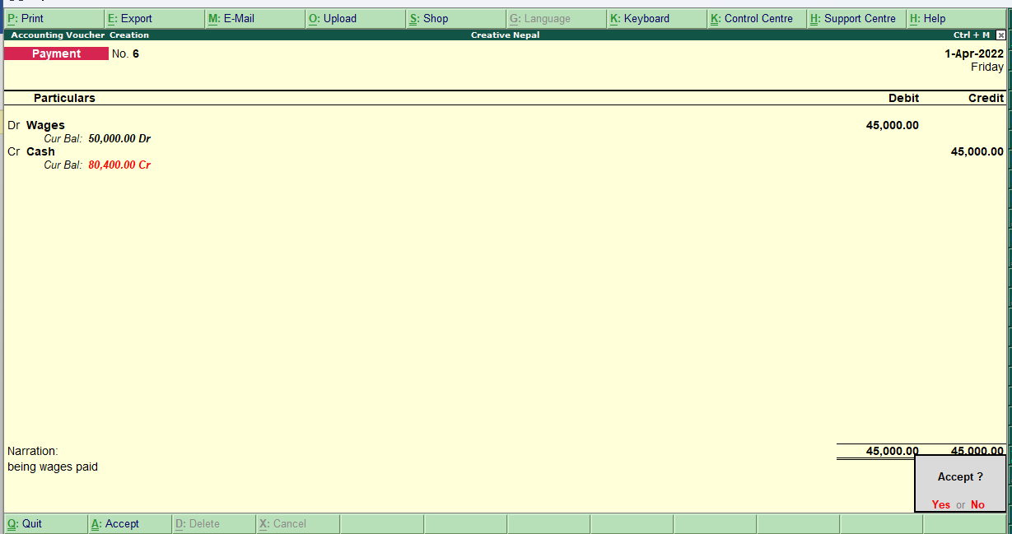

**Receipts(F6):**

Receipts are the amount of money received by a business during one accounting period. Receipts are cash sales, as well as money received on a customer's account. Receipts also include any cash received in the business from any source, including loan or credit line proceeds or funding from investors.

Example:

**Discount received Rs 5000**

cash a/c ………Dr.5000

To discount received a/c…..5000

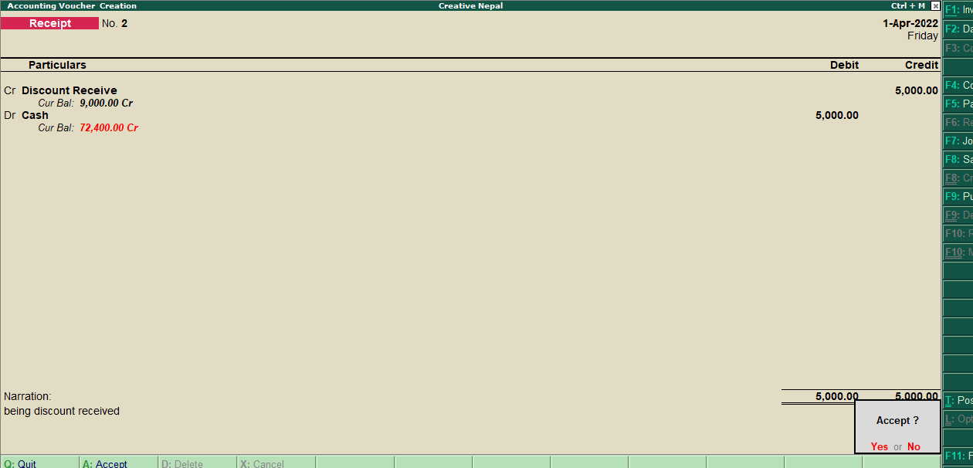

**Dividend received Rs 4000**

cash a/c ………Dr.4000

To dividend received a/c…..4000

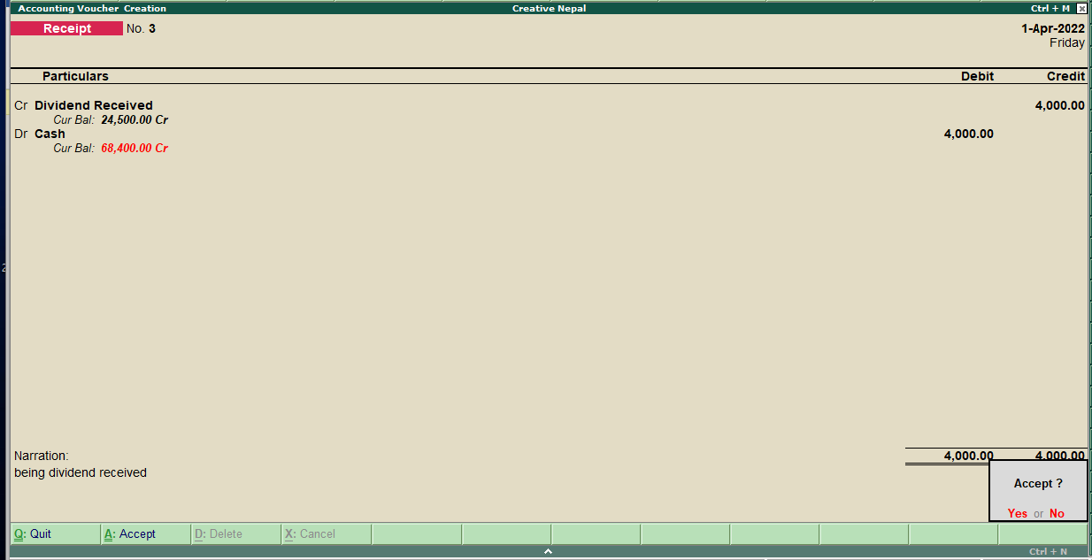

**interest received Rs 2500**

cash a/c ………Dr.2500

To interest received a/c…..2500

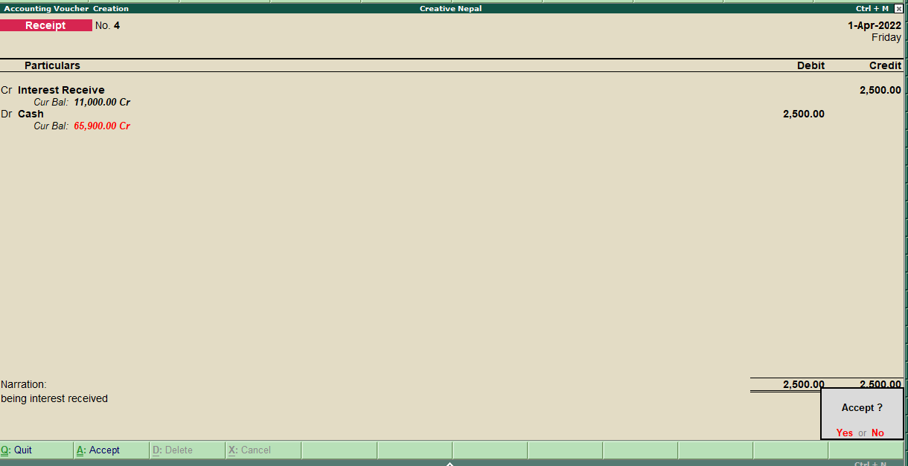

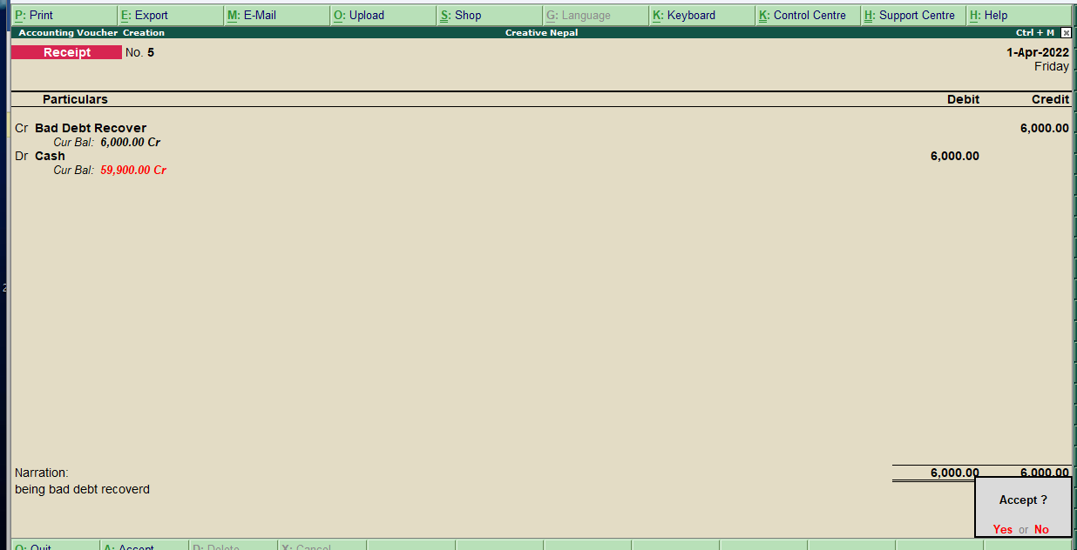

**Bad debt recover Rs 6000**

cash a/c ………Dr.6000

To bad debt recover a/c…..6000

**Conta Voucher (F4)**

As per the Accounting Principles Contra entry refers to transactions involving cash and bank account.

When you do internal funds transfer from one bank account to another bank account or cash withdrawals from a bank or cash deposited in a bank account in these cases you have to pass entry by using the contra voucher in Tally ERP9.

**Cash is deposited to the bank**

while depositing cash into the bank we write cash on the credit side and bank on the debit side.

Example

**Cash deposited to global bank 10,000**

Global bank a/c ………Dr.10,000

To cash a/c…..10,000

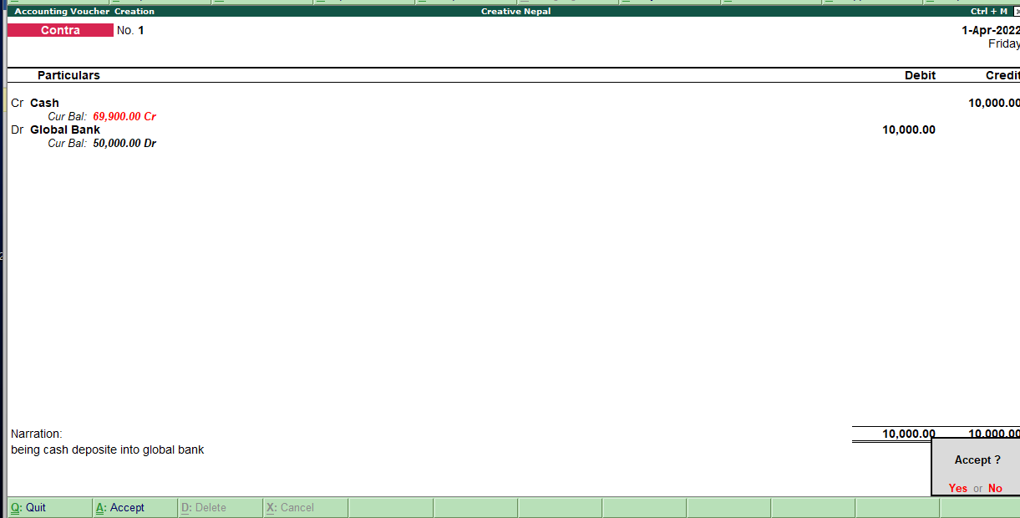

**Cash deposited to NIC Asia bank 10,000**

NIC Asia bank a/c ………Dr.200,000

To cash a/c…..200,000

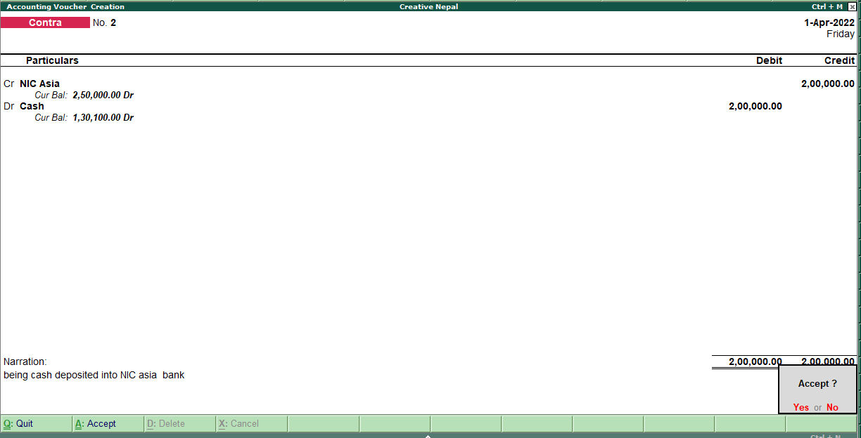

**Cash withdrawal from a bank account**

While withdrawal of cash from the bank account, we write cash on debit and bank in credit.

Example

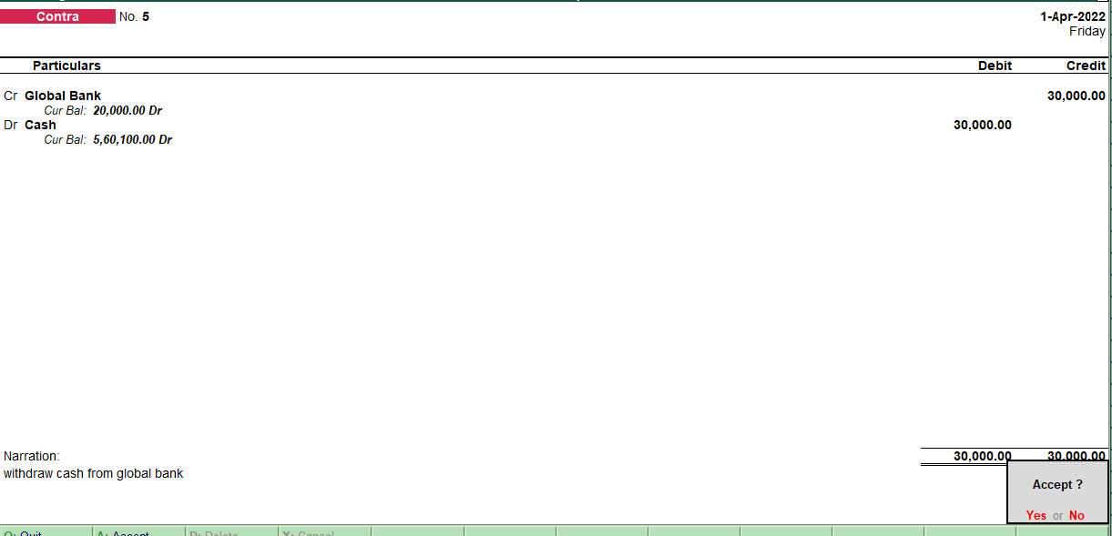

**Cash withdraw from global bank 10,000**

Cash a/c ………Dr.20,000

To global bank a/c…..20,000

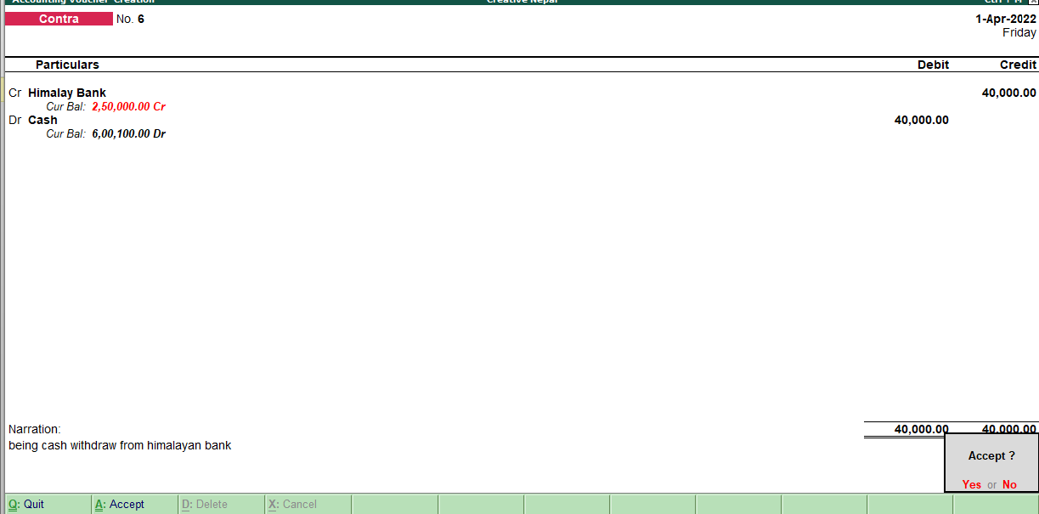

**Cash withdraw from prabhu bank 40,000**

Cash a/c ………Dr.20,000

To prabhu bank a/c…..20,000

**Cash withdraw from himalayan bank 40,000**

Cash a/c ………Dr.40,000

To himalayan bank a/c…..40,000

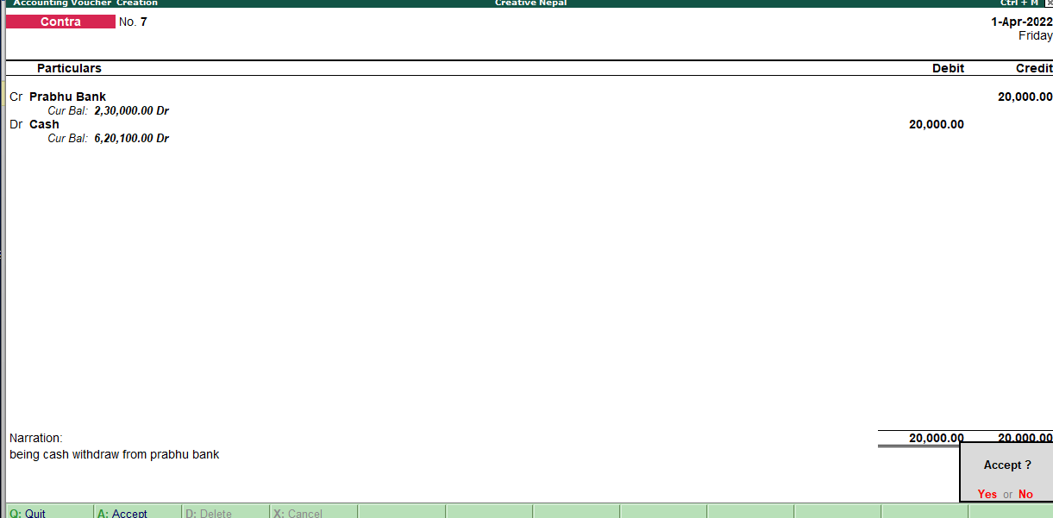

**Journal(F7):**

A journal is**a detailed account that records all the financial transactions of a business, to be used for the future reconciling of accounts and the transfer of information to other official accounting**records, such as the general ledger. But in tally,we only record the payables or receivables since payment and receipts are already there.

Example

**Outstanding wages paid 35000**

wages a/c ………Dr.35,000

To outstanding wages a/c..35,000

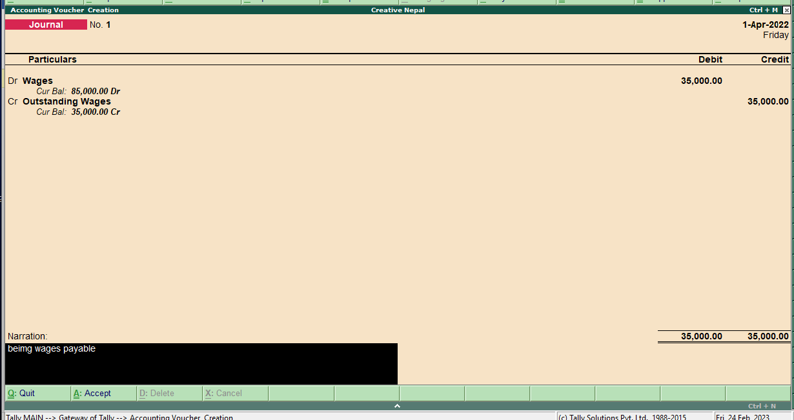

**O/s audit fee paid 2000**

Audit fee a/c ………Dr.2000

To O/s audit fee a/c…..2000

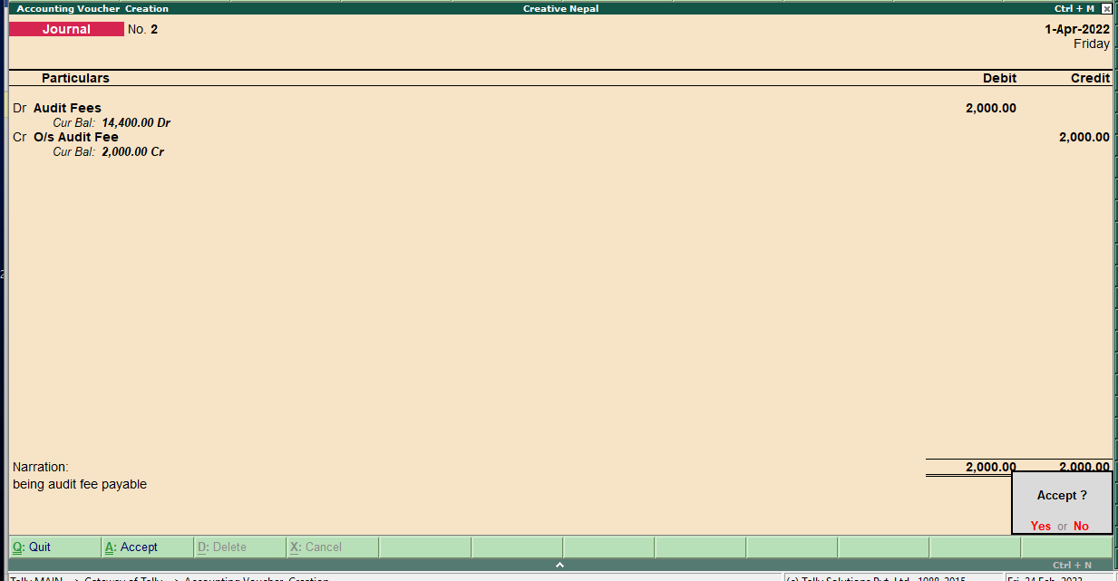

**Interest receivable paid 2300**

Interest receivable a/c ..Dr.2300

To interest receive a/c…..2300

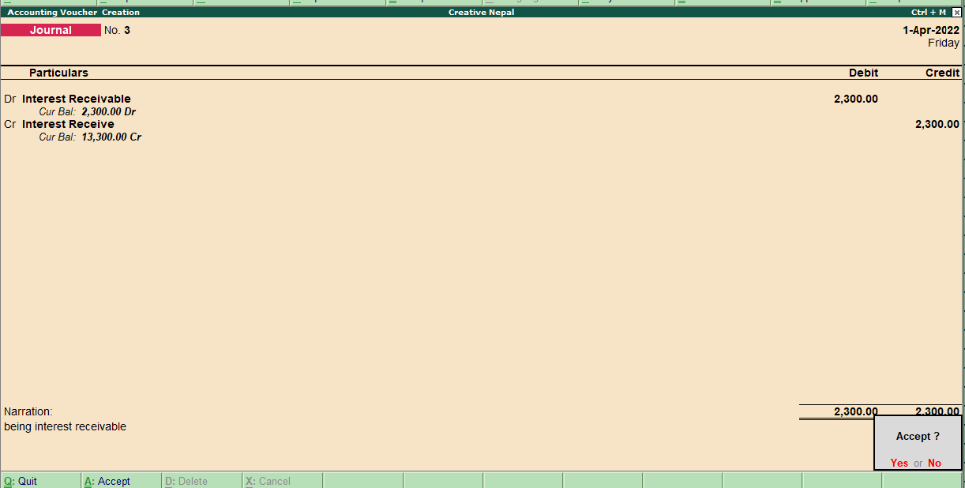

**dividend receivable paid 6000**

dividend receivable a/c ..Dr.6000

To dividend receive a/c…..6000

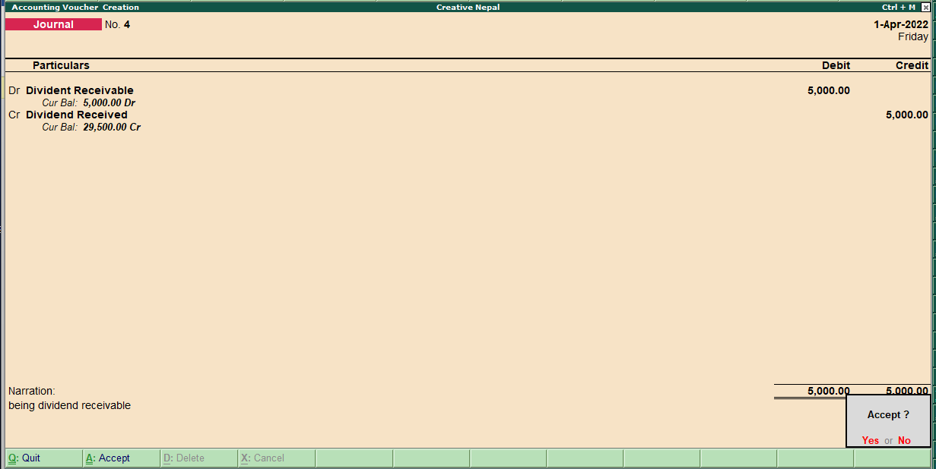

**Sales(F8)**

The term **sales** refer to the revenues earned when a company sells its goods, products, merchandise, etc. When a company sells a noncurrent asset that had been used in its business.

Example:

**Goods sold on Rs. 200,000**

Cash a/c ..Dr.200,000

To sales a/c…..20,000

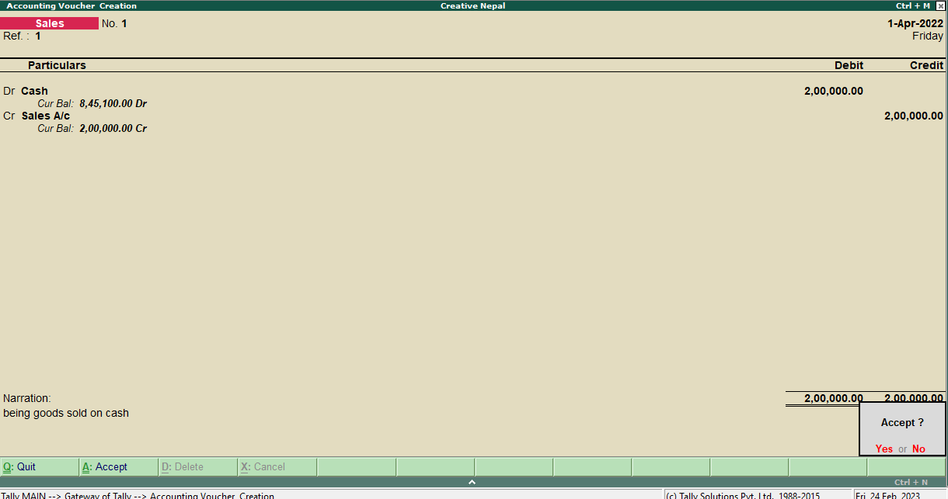

**Goods sold on Rs. 40,000**

Cash a/c ..Dr.40,000

To sales a/c…..40,000

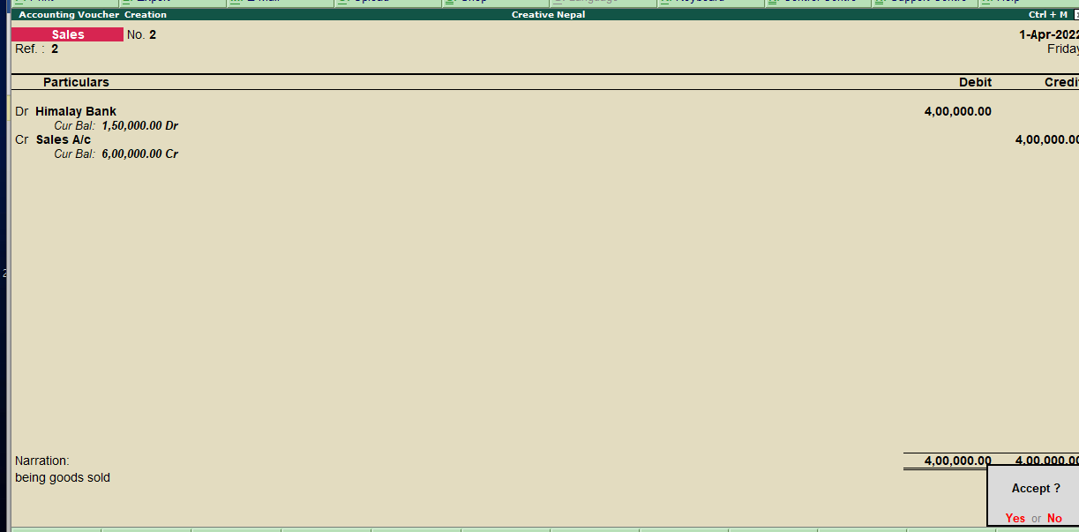

**Purchase(F9):**

A purchase involves the acquisition of goods or services in exchange for a payment of some kind. The payment is usually in cash or credit (to be paid later).

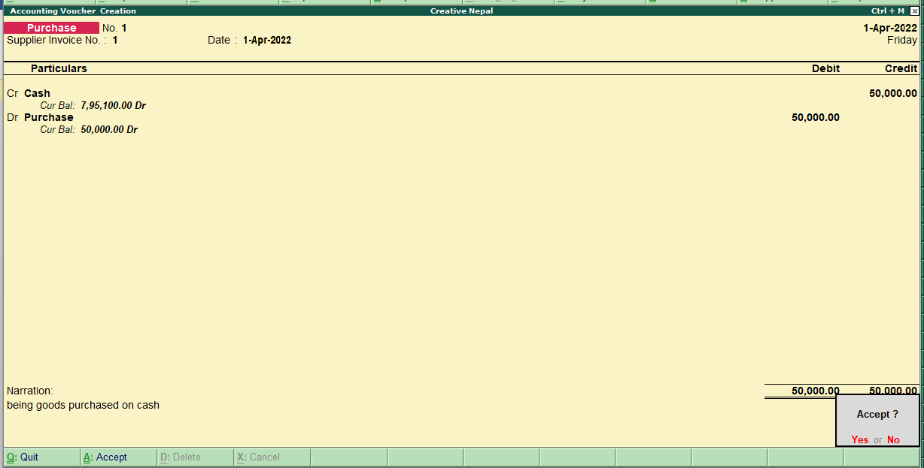

**Goods purchased paid by cheque Rs. 300,000**

purchase a/c ..Dr.300,000

To cash a/c…..300,000

**Goods purchased on Rs. 60,000**

purchase a/c ..Dr.60,000

To cash a/c…..60,000

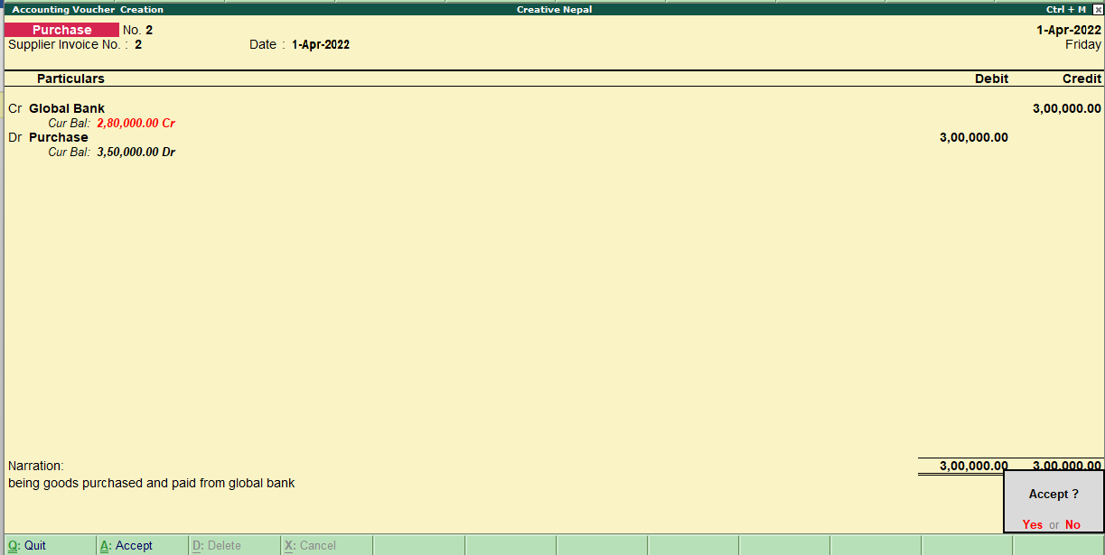

**Daybook**

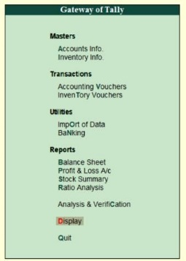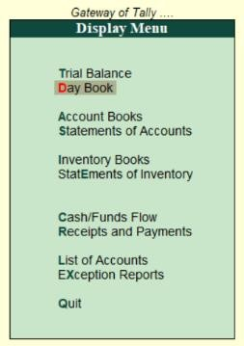A daybook is a book of original entries in which an accountant records transactions by date, as they occur. This information is later transferred into a ledger, from which the information is summarized into a set of financial statements. To view all the transactions we entered such as contra, receipts, and payment we have to follow the following steps:

* Go to **Gateway of Tally.**
* Click on **Display** in the Reports Section.
* Click on **Day Book or enter D** on the keyboard.

Condensed

In tally, we can view the day book in condensed mode.

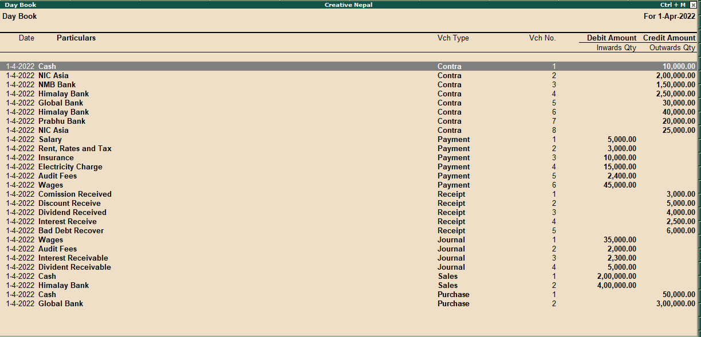

Detailed(F1)  
To view the day book in tally, you can simply click on Detailed or enter F1.

